**Project Design Phase-II**

**Technology Stack (Architecture & Stack)**

|  |  |
| --- | --- |
| Date | 27 June 2025 |
| Team ID | LTVIP2025TMID31894 |
| Project Name | Health AI: Intelligent Healthcare Assistant Using IBM Granite |
| Maximum Marks | 4 Marks |

**Technical Architecture:**

**Technology Stack**

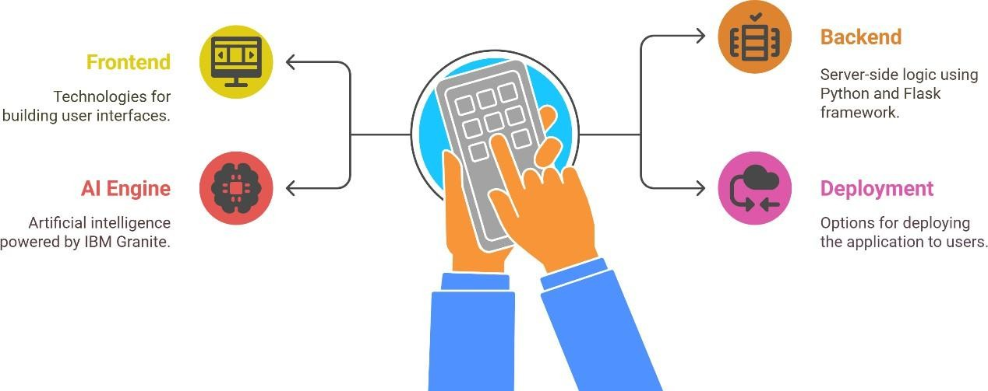

| **Component** | **Description** | **Technology Used** |
| --- | --- | --- |
| **User Interface** | Frontend interface where users interact with different tools (Symptom checker, Chat, etc.) | Gradio (Python), React.js (optional) |
| **Input Translator** | Translates user queries (e.g., Hindi, Telugu) to English for AI processing | translate Python package |
| **Prompt Engine** | Dynamically generates structured prompts per tab (symptoms, remedies, etc.) | Python string logic / Template-based |
| **AI Model** | Generates health-related responses based on input and prompts | IBM Granite 3.3B via transformers |
| **Response Handler** | Processes raw model output into readable, user-safe format | Python logic |
| **Symptom Analyzer** | Accepts symptoms and predicts potential conditions | Prompt + Model pipeline |
| **Remedy Generator** | Suggests home remedies based on user input disease | Prompt + Model pipeline |
| **Medication Info** | Provides general drug names and treatment info (non-prescriptive) | Prompt + Model pipeline |
| **Encyclopedia Engine** | Gives full summary of a disease, including causes and prevention | Prompt + Model pipeline |
| **Chat Assistant** | Responds empathetically to general health-related questions | Prompt + Model pipeline |
| **Deployment Host** | Executes and displays the application in a browser | Google Colab / Hugging Face Spaces |